Heal Rewilding Somerset
Micro moth report 2023
By
Jenny Vickers
Introduction
The following is a report on the micro moths found at Heal Somerset near Witham Friary for the year 2023.

The methods used for detection were visual search for leaf mines/early stages and adults, most of which were photographed and a selection taken home to rear through to aid identification. Early stages/leaf mines indicate the species of micro moth definitely using the food plants available on site and crucially, proof of breeding. The work was undertaken between July and October.

For this report, the parts of the site covered were the following fields E1, N6, N7, S1 and S2. However it quickly became apparent that in order to record successfully and thoroughly it was necessary to reduce the number of fields surveyed. Therefore the three fields selected for continued survey were E1, N7 and S2.

Species
The figure at the start of each species is based on the Checklist of the Lepidoptera of the British Isles by D Agassiz, S Beavan & R Heckford (2013). The species (in italics) are placed under their respective families and with the most up to date common names in brackets along with the foodplant used where applicable.

The following is the criteria for national status in Great Britain as found in The Review of the Status of Microlepidoptera in Britain by Tony Davis 2012.

pRDB 1 – Occurs in 5 or less 10km squares
pRDB 2 – Occurs in 6 – 10 10km squares
pRDB 3 – Occurs in 11 – 15 10km squares
pRDB K – Suspected, but not definitely known, to be in one of the above categories but not enough information available to say which.
Nationally Scarce A – Occurs in 16 – 30 10km squares
Nationally Scarce B – Occurs in 31 to 100 10km squares
Local – Occurs in 101 – 300 10km squares
Common – Occurs in more than 300 10km squares

NEPTICULIDAE
4.010 Stigmella microtheriella (Nut-tree Dot) – mine on Hazel (Corylus avellana)
National status – common

4.015 Stigmella anomalella (Rose Dot) – mine on Dog Rose (Rosa canina)
National status – common

4.018 Stigmella ulmivora (Barred Elm Dot) – mine on Elm sp (Ulmus sp)
National status – local

4.022 Stigmella regiella (Purple-shot Dot) – mine on Hawthorn (Crataegus monogyna)
National status – local

4.023 Stigmella crataegella (Hawthorn Dot) – mine on Hawthorn (Crataegus monogyna)
National status – common

4.026 Stigmella oxyacanthella (Fruit-tree Dot) – mine on Hawthorn (Crataegus monogyna)
National status – common

4.030 Stigmella hybnerella (Shining Hawthorn Dot) – mine on Hawthorn (Crataegus monogyna)
National status – common

4.032 Stigmella floslactella (Speckled Hazel Dot) – mine on Hazel (Corylus avellana)
National status – common

4.035 Stigmella salicis cluster 1 sensu stricto (Sallow Dot) – mine on Goat Willow (Salix caprea) egg underside
National status – common

4.0351 Stigmella salicis cluster 6 (Un-named) – mine on Goat Willow (Salix caprea) egg upperside
National status – undetermined at present

4.042 Stigmella plagicolella (Blue-shot Dot) - mine on Blackthorn (Prunus spinosa)
National status – common

4.043 Stigmella lemniscella (Beautiful Elm Dot) – mine on Elm sp (Ulmus sp)
National status – common

4.045 Stigmella aurella (Golden Dot) – mine on Bramble (Rubus fruticosus agg.)
National status – common

4.054 Stigmella perpygmaeella (Least Hawthorn Dot) – mine on Hawthorn (Crataegus monogyna)
National status – common

4.058 Stigmella basiguttella (Shoulder-spot Dot) – mine on Oak (Quercus robur)
National status – common

4.061 Stigmella atricapitella (Black-headed Dot) – mine on Oak (Quercus robur)
National status - common

4.075 Etainia louisella (Maple Seed Dot) – mine on Field Maple samara (Acer campestre)
National status – local

4.082 Ectoedemia intimella (White-spot Sallow Dot) – mine on Goat Willow (Salix caprea)
National status – local

4.089 Ectoedemia albifasciella (White-banded Dot) – mine on Oak (Quercus robur)
National status – common

4.090 Ectoedemia subbimaculella (Broken-barred Oak Dot) – mine on Oak (Quercus robur)
National status – common

4.091 Ectoedemia heringi (White-spot Dot) – mine on Oak (Quercus robur)
National status – local

4.095 Ectoedemia atricollis (Barred Fruit-tree Dot) – mine on Hawthorn (Crataegus monogyna)
National status – common

4.097 Ectoedemia rubivora (Dewberry Dot) – mines on Bramble (Rubus fruticosus agg)
National status – nationally scarce B

HELIOZELIDAE
6.001 Antispila metallella (Shining Dogwood Cutter) – mine on Dogwood (Cornus sanguinea)
National status – local

6.002 Antispila petryi (Dogwood Cutter) – mine on Dogwood (Cornus sanguinea)
National status – local

TISCHERIIDAE
10.001 Tischera ekebladella (Oak Blotch-miner) – mine on Oak (Quercus robur)
National status – common

10.003 Coptotriche marginea (Bramble Blotch-miner) – mine on Bramble (Rubus fruticosus agg.)
National status – common
Notes –mines collected 25/07 – adults emerged 10/08 and 18/08

BUCCULATRICIDAE
14.010 Bucculatrix ulmella (Oak Tuft) – mine on Oak (Quercus robur)
National status – common

14.012 Bucculatrix bechsteinella (Hawthorn Tuft) – mine on Hawthorn (Crataegus monogyna)
National status – local

GRACILLARIIDAE
15.010 Caloptilia stigmatella (Willow Stilt) – mine on Goat Willow (Salix caprea)
National status – common

15.028 Parornix anglicella (Hawthorn Parornix) – mine on Hawthorn (Crataegus monogyna)
National status – common

15.029 Parornix devoniella (Hazel Parornix) – mine on Hazel (Corylus avellana)
National status – common

15.032 Parornix finitimella (Southern Blackthorn Parornix) – mine on Blackthorn (Prunus spinosa)
National status – common

15.033 Parornix torquillella (Blackthorn Parornix) – mine on Blackthorn (Prunus spinosa)
National status - common

15.034 Phyllonorycter harrisella (White Oak Leaf-miner) – mine on Oak (Quercus robur)
National status – common
Notes – mines collected 07/08, adults emerged 13/08 and 15/08

15.039 Phyllonorycter quercifoliella (Common Oak Leaf-miner) – mine on Oak (Quercus robur)
National status – common
Notes – mines collected 05/07, 07/08, 16/08, adults emerged 11/07, 17/07, 13/08, 17/08, 18/08, 20/08 and 25/08

15.043 Phyllonorycter oxyacanthae (Common Thorn Leaf-miner) – mine on Hawthorn (Crataegus monogyna)
National status – common
Notes – mine collected 16/08, adult emerged 24/08

15.049 Phyllonorycter spinicolella (Blackthorn Leaf-miner) – mine on Blackthorn (Prunus spinosa)
National status – common

15.052 Phyllonorycter corylifoliella (Hawthorn Leaf-miner) – mine on Hawthorn (Crataegus monogyna)
National status – common
Notes – mine collected 25/07, adult emerged 03/08

15.053 Phyllonorycter leucographella (Firethorn Leaf-miner) – mine on Hawthorn (Crataegus monogyna)
National status – common

15.054 Phyllonorycter viminiella (Willow Leaf-miner) – mine on Goat Willow (Salix caprea)
National status – common
Notes – mines collected 07/08 and 16/08, adults emerged 16/08, 19/08, 21/08, 23/08 and 25/08

15.057 Phyllonorycter dubitella (Goat Willow Leaf-miner) – mine on Goat Willow (Salix caprea)
National status – Nationally Scarce B
Notes – mine collected 05/07, adult emerged 11/07

15.064 Phyllonorycter coryli (Nut Leaf Blister Moth) – mine on Hazel (Corylus avellana)
National status – common

15.067 Phyllonorycter rajella (Common Alder Leaf-miner) – mine on Alder (Alnus glutinosa)
National status – common

15.071 Phyllonorycter nigrescentella (Vetch Leaf-miner) – mine on Bush Vetch (Vicia sepium)
National status – pRDB3

15.073 Phyllonorycter lautella (Small Oak Leaf-miner) – mine on Oak (Quercus robur)
National status - local

15.078 Phyllonorycter tristrigella (Elm Leaf-miner) – mine on Elm sp (Ulmus sp)
National status – common
Notes – mines collected 05/07, adults emerged 17/07 and 29/07

15.080 Phyllonorycter froelichiella (Large Alder Leaf-miner) – mine on Alder (Alnus glutinosa)
National status - common

15.081 Phyllonorycter nicellii (Hazel Leaf-miner) – mine on Hazel (Corylus avellana)
National status – common
Notes – mines collected 07/08, adults emerged 16/08 and 17/08

15.082 Phyllonorycter kleemannella (Shining Alder Leaf-miner) – mine on Alder (Alnus glutinosa)
National status – common

15.083 Phyllonorycter trifasciella (Banded Honeysuckle Leaf-miner) – mine on Honeysuckle (Lonicera periclymenum)
National status – common
Notes – mines collected 11/10, adults emerged 11/10 and 14/10

15.084 Phyllonorycter acerifoliella (Maple Leaf-miner) – mine on Field Maple (Acer campestre)
National status – common

YPONOMEUTIDAE
16.004 Yponomeuta cagnagella (Spindle Ermine) – larval web on Spindle (Euonymus europaeus)
National status – common

LYONETIIDAE
21.001 Lyonetia clerkella (Apple Leaf-miner) – mine Hawthorn (Crataegus monogyna)
National status – common

21.002 Lyonetia prunifoliella (Blackthorn Blister Moth) – mine on Blackthorn (Prunus spinosa)
National status – pRDB1
Notes – mine collected 17/10, adult emerged 29/11

OECOPHORIDAE
28.014 Crassa unitella (Brown Bark Moth) – adult
National status – common

PELEOPODIDAE
31.001 Carcina quercana (Oak Longhorn) – feeding signs on Oak (Quercus robur) and Alder (Alnus glutinosa)
National status – common

DEPRESSARIIDAE
32.017 Agonopterix arenella (Brindled Buff) – larvae in rolled leaf of Burdock (Arctium sp)
National status – Common
Notes – leaf spinning collected 05/07, adult emerged 03/08

GELECHIIDAE
35.109 Scrobipalpa acuminatella (Common Thistle Miner) – mine on Creeping Thistle (Cirsium arvense)
National status – common

COLEOPHORIDAE
37.006 Coleophora gryphipennella (Rose Case-bearer) – larval case on Dog Rose (Rosa canina)
National status - common

37.022 Coleophora lusciniaepennella (Willow Case-bearer) – larval case on Goat Willow (Salix caprea)
National status - common

37.032 Coleophora albitarsella (White-legged Case-bearer) – larval case on Ground Ivy (Glechoma hederacea)
National status - local

37.049 Coleophora anatinpennella (Pistol Case-bearer) – larval case on Blackthorn (Prunus spinosa)
National status – local

37.073 Coleophora alticolella (Common Rush Case-bearer) – larval case on Rush sp (Juncus sp)
National status – common

ELACHISTIDAE
38.037 Elachista canapennella (Common Grass-miner) – adults- moth trap 27.09.2023 – det Paul Wilkins
National status – common

MOMPHIDAE
40.010 Mompha epilobiella (Buff Mompha) – larval spinning on Great Willowherb (Epilobium hirsutum)
National status – common
Notes – leaf spinnings collected 05/07, adults emerged 16/07 and 08/08

EPERMENIIDAE
47.005 Epermenia chaerophyllella (Common Ridge-back) – larvae on Hogweed (Heracleum sphondylium)
National status – common
Notes – larva collected 29/09, adult emerged 19/11

CHOREUTIDAE
48.001 Anthophila fabriciana (Nettle-tap Moth) – adult
National status – common

TORTRICIDAE
49.066 Acleris laterana (Dark-marked Tortrix) – adult – moth trap 27.09.2023 – det Paul Wilkins
National status – common

49.070 Acleris rhombana (Rhomboid Tortrix) – adult – moth trap 27,09.2023
National status - common

49.166 Celypha lacunana (Common Marble) – adults
National status – common

49.279 Gypsonoma dealbana (Common Cloaked Tortrix) – frass covered silk tube on Oak (Quercus robur), Goat Willow (Salix caprea)
National status – common

49.341 Cydia splendana (Marbled Piercer) – adult
National status – Common

49.379 Pammene aurana (Double Orange-spot) – larva in spun seedheads of Hogweed (Heracleum sphondylium)
National status – common

CRAMBIDAE
63.038 Pleuroptya ruralis (Mother of Pearl) – leaf roll on Nettle (Urtica dioica)
National status - common

63.074 Eudonia mercurella (Garden Grey) – adult
National status - common

63.080 Chrysoteuchia culmella (Garden Grass-moth) – adults
National status – common

63.091 Agriphila latistria (White-streaked Grass-moth) – adult
National status - local

63.093 Agriphila straminella (Straw Grass-moth) – adult
National status – Common

Below is a small selection of photos taken of some of the micro moths found on site this year some of which show finding the early stages and rearing through to the adult moth.

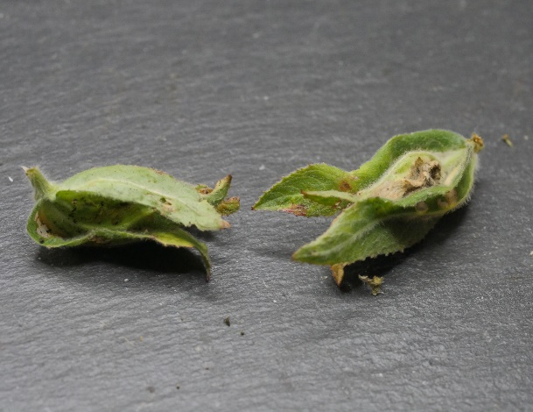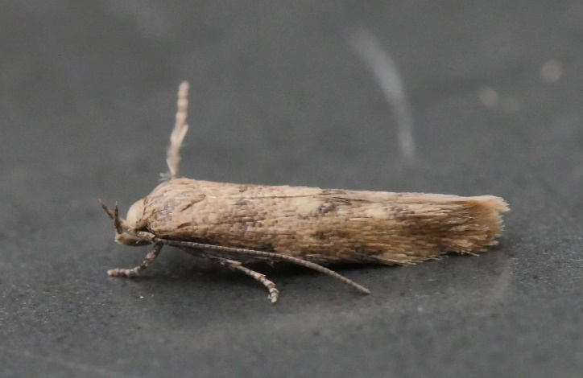
Mompha epilobiella – leaf spinning on Great Willowherb, adult emerged two weeks later.
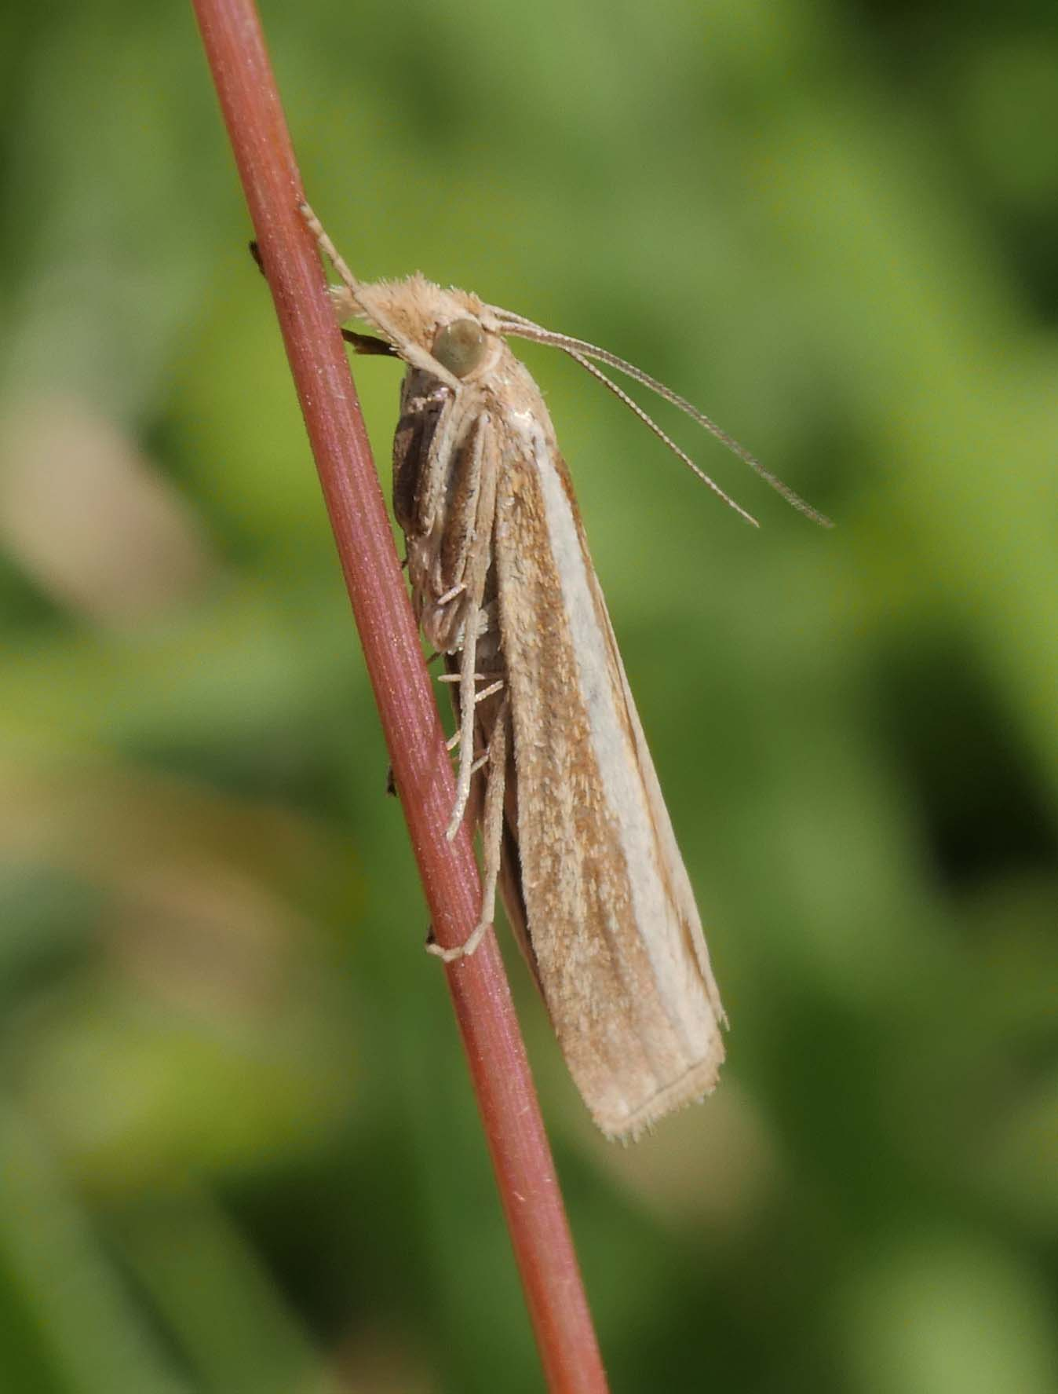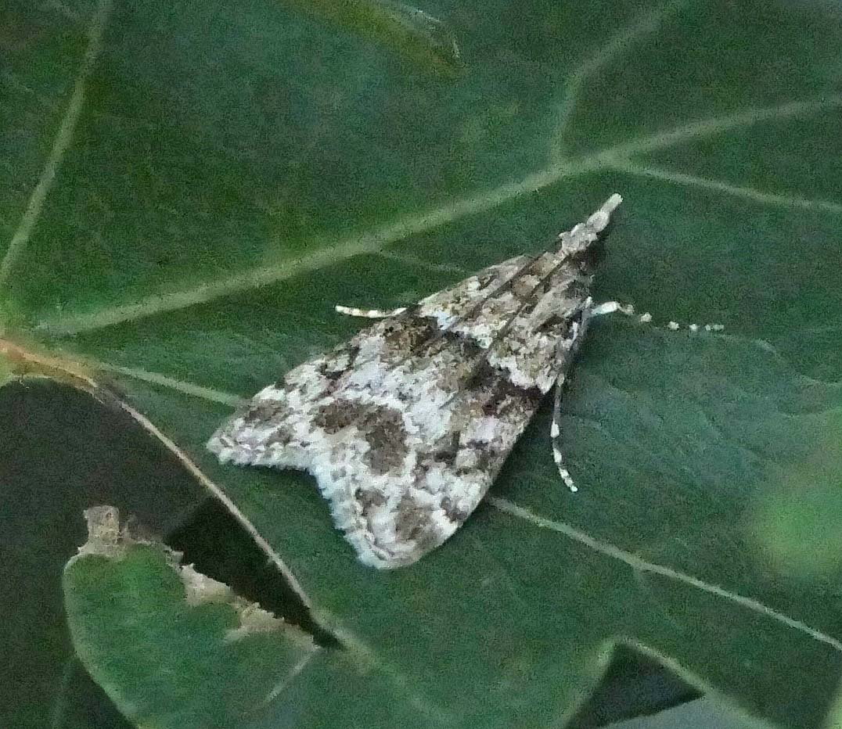
Agriphila latistria Eudonia mercurella

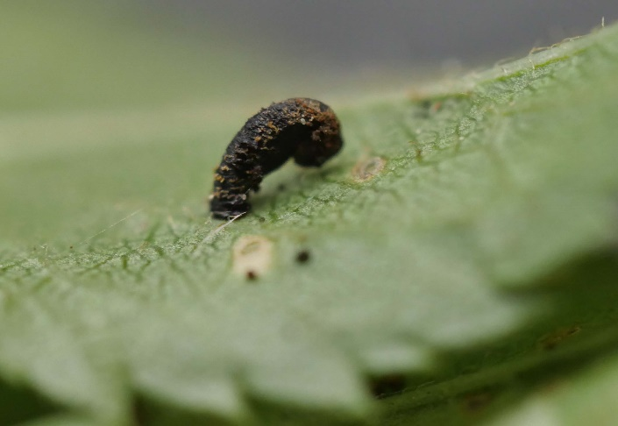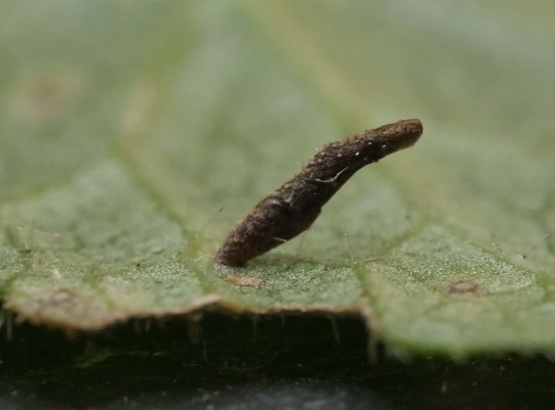
Coleophora anatipennella Coleophora albitarsella

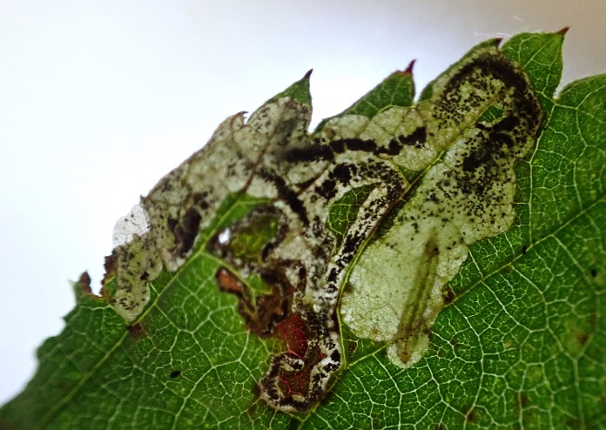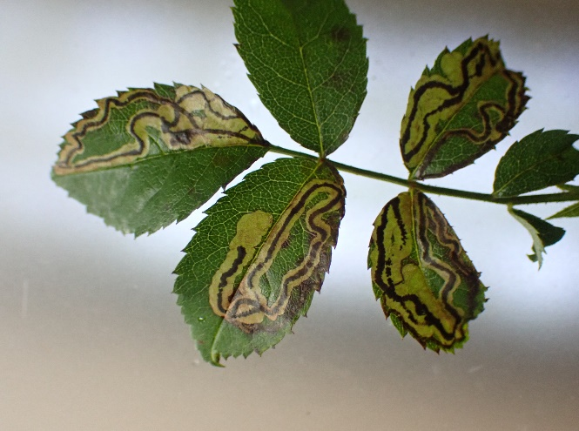
Ectoedemia rubivora Stigmella anomalella

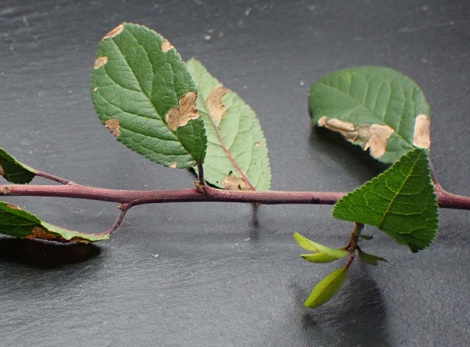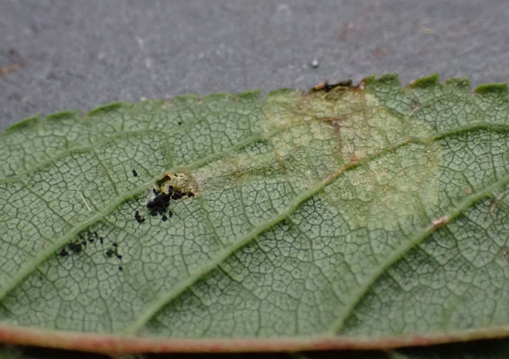
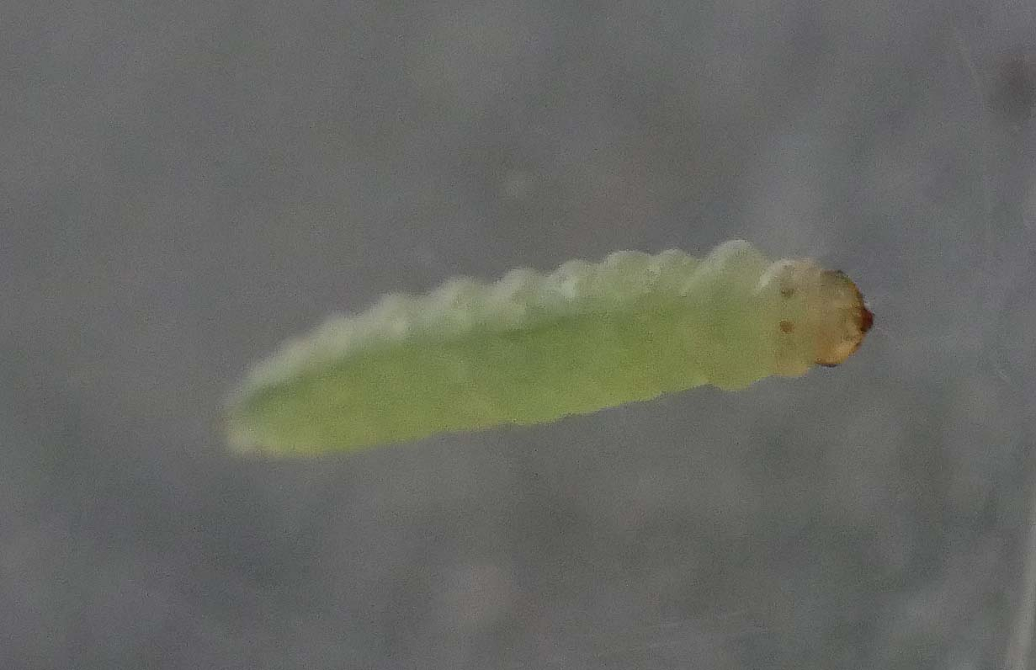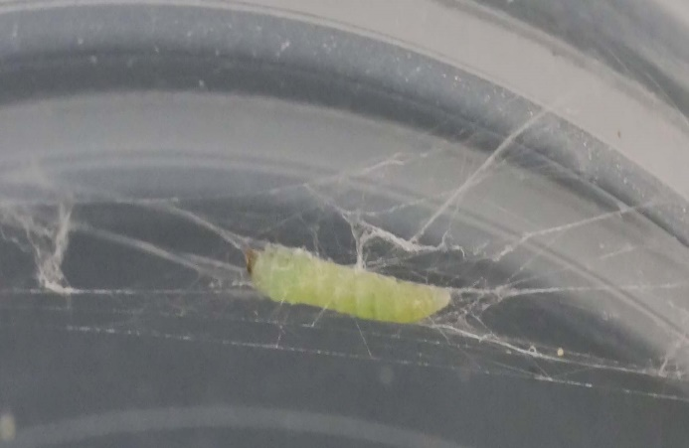
Lyonetia prunifoliella pRDB1 – mines on Blackthorn. Larva left the mine and created its distinctive hammock like cocoon.

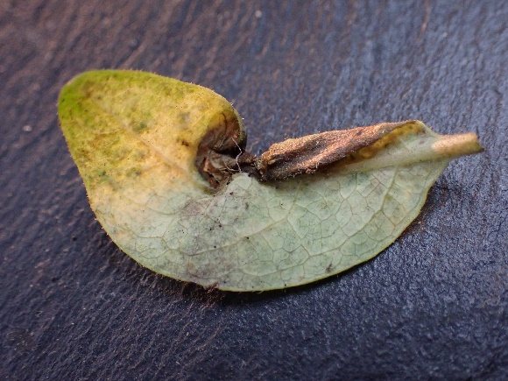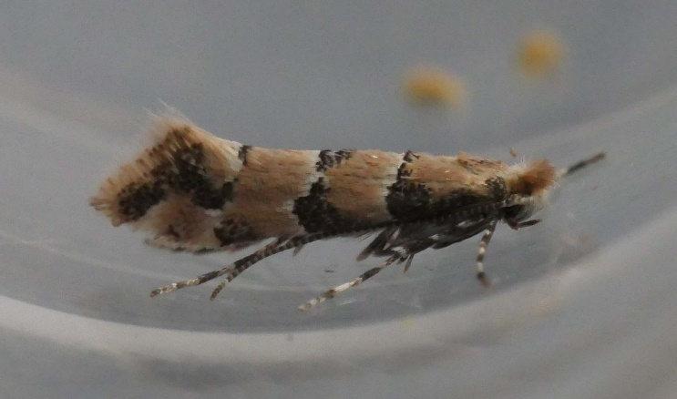
Phyllonorycter trifasciella – mine on Honeysuckle, adult emerged the same day!

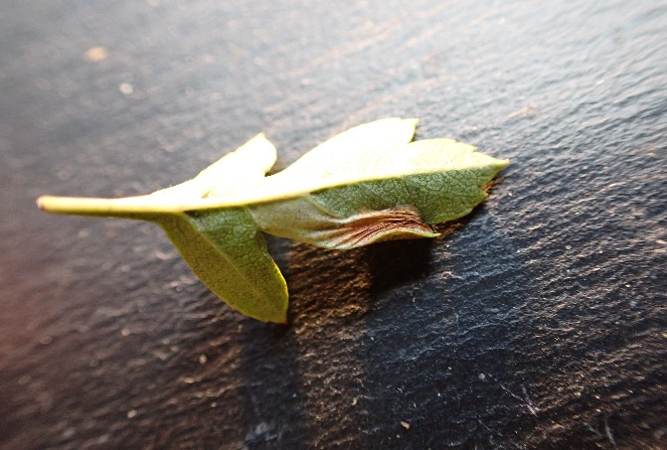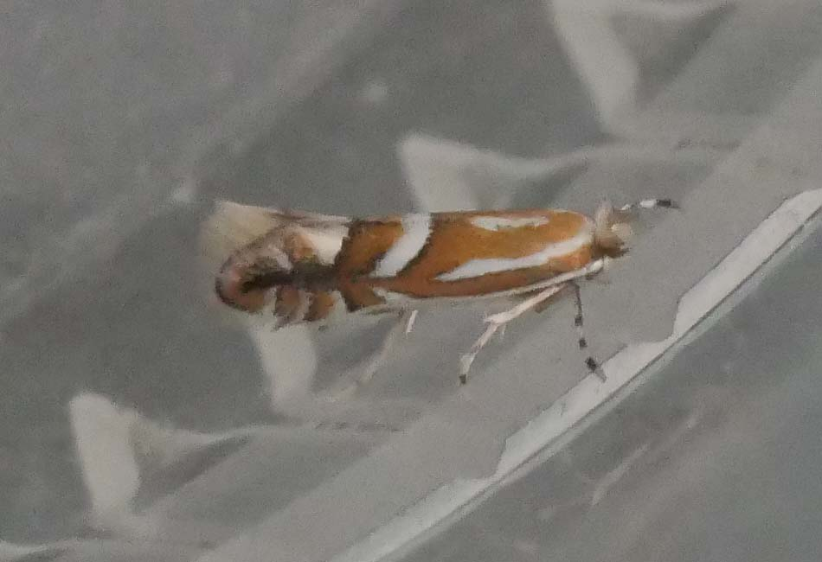
Phyllonorycter oxyacanthae – mine on Hawthorn, adult emerged a week later

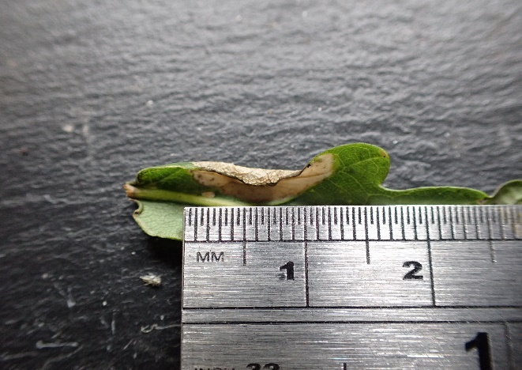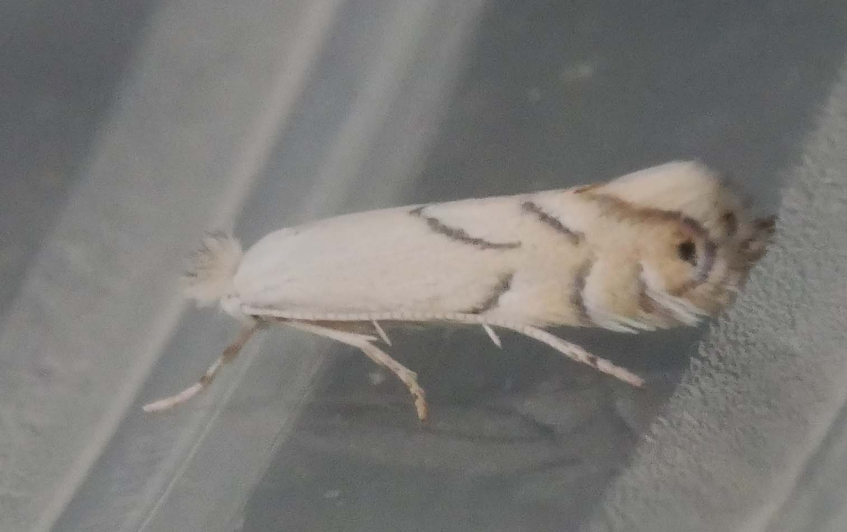
Phyllonorycter harrisella – mine on Oak, adult emerged a week later.

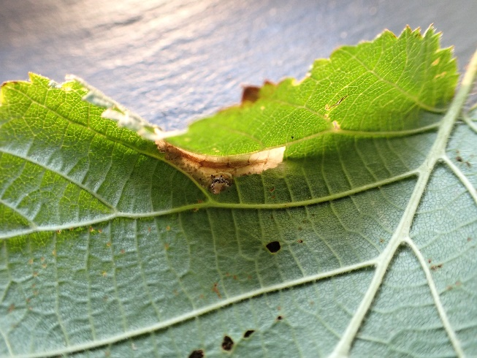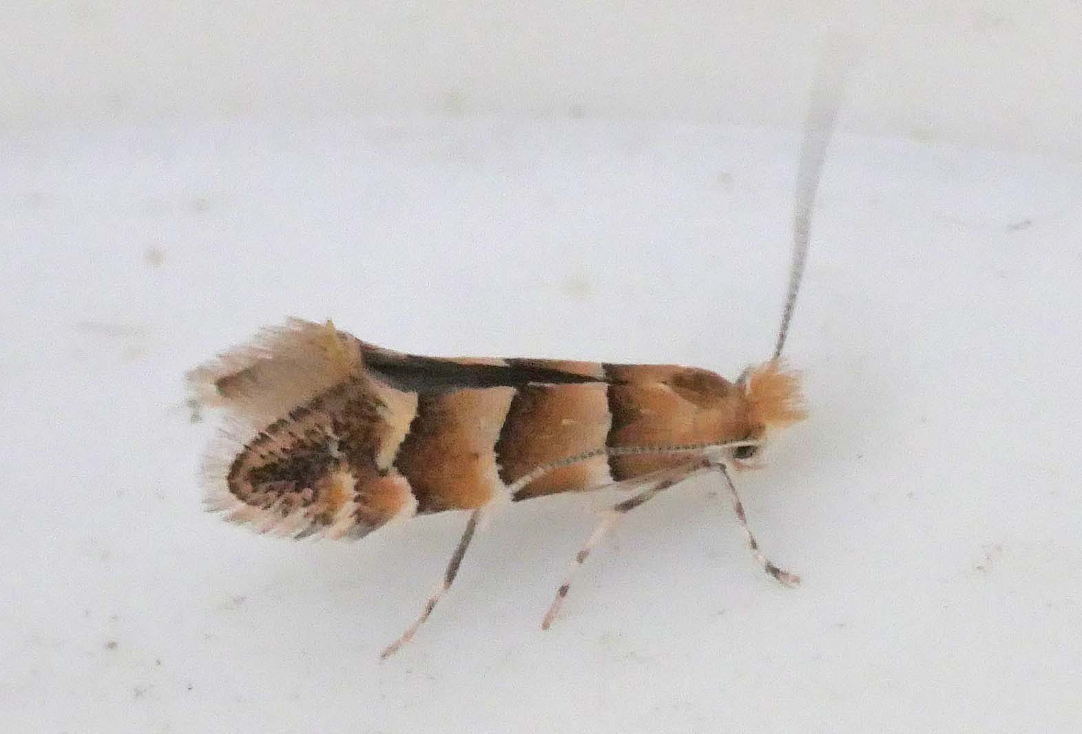
Phyllonorycter nicelii – mine on Hazel, adult emerged a week later.

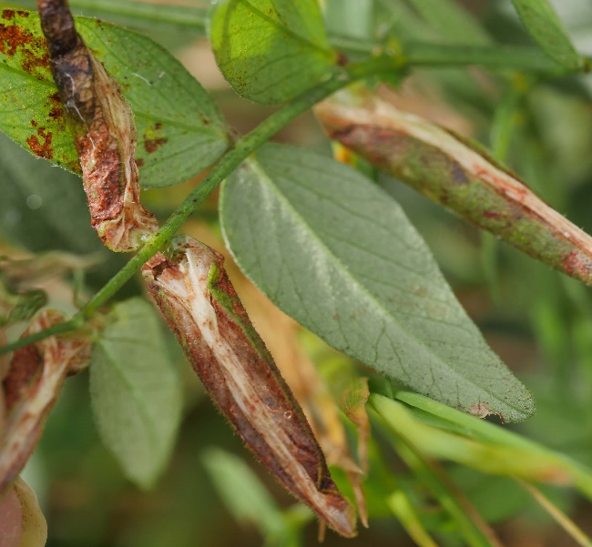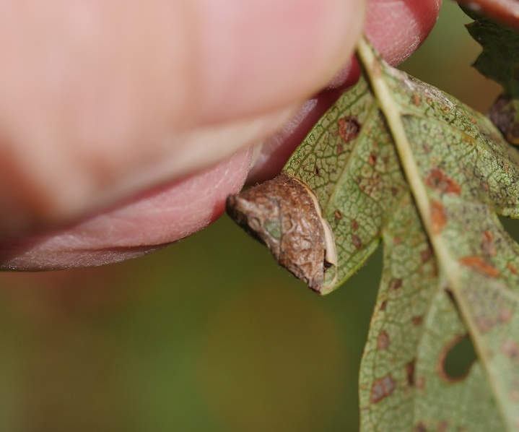
Phyllonorycter nigrescentella Parornix anglicella

Sources of information
Books:
STERLING, P, PARSONS, M, & LEWINGTON, R. (2023). Field Guide to the Micro Moths of Great Britain and Ireland. British Wildlife Publishing, Gillingham.
MANLEY, C (2015) British Moths (Second edition) A Photographic Guide to the Moths of Britain and Ireland. Bloomsbury
EMMET, A M (reprint 2017). A Field Guide to the Smaller British Lepidoptera. The British Entomological and Natural History Society (revised by JR Langmaid, SM Palmer and MR Young)
SMART, B. (2017) Micro-moth Field Tips. A guide to finding the early stages in Lancashire and Cheshire. Lancashire & Cheshire Fauna Society
SMART, B. (2021) Micro-moth Field Tips. A guide to finding the early stages in Lancashire and Cheshire. Lancashire & Cheshire Fauna Society
Websites:
British Leaf miner website: www.leafmines.co.uk
UK Moths website: www.ukmoths.org.uk
Somerset Moth Group website: www.somersetmothgroup.org.uk
Butterfly Conservation website: http://www.mothscount.org/
Butterfly Conservation The Review of the Status of Microlepidoptera in Britain by Tony Davis 2012.
The Leaf and Stem Mines of British Flies and other Insects: http://www.ukflymines.co.uk/index.php
Eggs, Larvae, Pupae and Adult Butterflies and Moths: http://ukleps.org/
Plant Parasites of Europe: https://bladmineerders.nl/
Lepiforum: www.lepiforum.de

Acknowledgements
I would like to thank the team at Heal Rewilding for permission to undertake survey work on site. Particularly Jan Stannard, Hannah Needham and Daniel Hill.

